**GENERATION GAP:**

**UNDERSTANDING AND OVERCOMING IT**

Have you ever felt like you're speaking a different language to your parents? Or that they don't understand why you like the things you do? If so, you're not alone. This is a phenomenon we call the "generation gap."

**What is the generation gap?**

The generation gap refers to the differences in beliefs, values, and lifestyles between different generations. It can occur between any two generations, but it's most commonly discussed between parents (the older generation) and their children (the younger generation). These differences can lead to misunderstandings, conflicts, and even strain in family relationships.



**Why does the generation gap exist?**

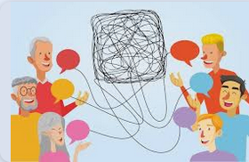

There are many reasons for the generation gap. One of the main reasons is the rapid pace of societal change. The world is evolving at a breakneck speed, with new technologies and information emerging every day. This makes it difficult for different generations to keep up with each other.

Additionally, differences in life experiences play a significant role. Your parents grew up in a different society than the one you're living in. They have different experiences, values, and perspectives. This can lead to different ways of looking at life.

Finally, differences in communication styles also contribute to the generation gap. Younger generations often use more social media and have different ways of communicating compared to older generations. This can create difficulties in understanding each other.

**How can we bridge the generation gap?**

While the generation gap can be challenging, it's not insurmountable. Here are some suggestions to help you improve your relationship with your parents:

**\* Open communication**: Talk to your parents honestly and sincerely about your feelings and thoughts. Listen to their perspectives and try to understand why they think the way they do.



**\*Spend quality time together:** Find opportunities to do activities together with your parents. This can strengthen your relationship and help you understand each other better.



**\*Mutual respect:** Remember that both you and your parents have the right to your own opinions. Respecting each other's viewpoints is crucial.

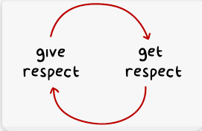

**\*Explain and share:** If you want your parents to understand your world, explain to them the things you're interested in. Share your hobbies, music, and movies with them.



**\*Learn from each other:** Each generation has its own strengths and weaknesses. Learning from each other is a good way to grow as a person.



The generation gap is a normal part of life. However, with effort from both sides, we can build strong and happy family relationships. Remember, your parents love you and want what's best for you. Try to understand and respect each other to overcome these challenges.