Vietnamese Women’s Day- October 20
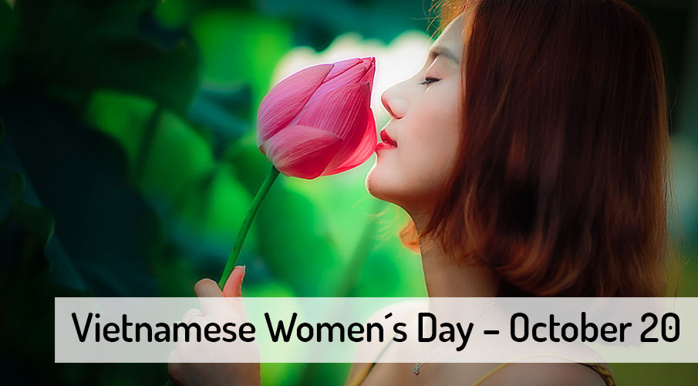

Observed every single year in Vietnam on October 20th, Vietnamese Women’s Day is a holiday that expresses love and equality for women. This holiday can be traced back to the 1930s and has been celebrated ever since. On this day, society can show their love and respect for women, and help advocate for women’s equality. It’s a day to recognize the achievements of women as well. And as is common with many holidays, it’s also a day to enjoy some good food.

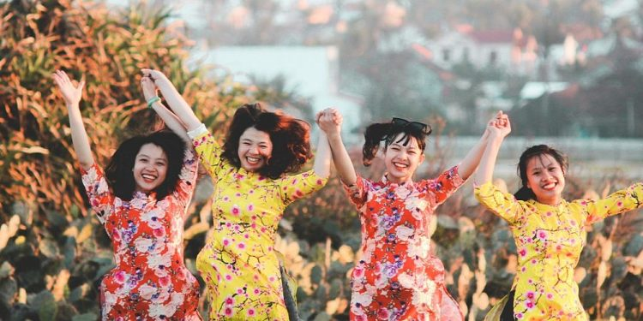

The History Of Vietnamese Women’s Day
This holiday goes back to October 20, 1930. This is when the Vietnam Women’s Union was officially established and this holiday was created to market that event to the public. Vietnamese Women’s Day thereby not only became the traditional holiday for this organization but also became a day when women all over Vietnam could be honored and celebrated.

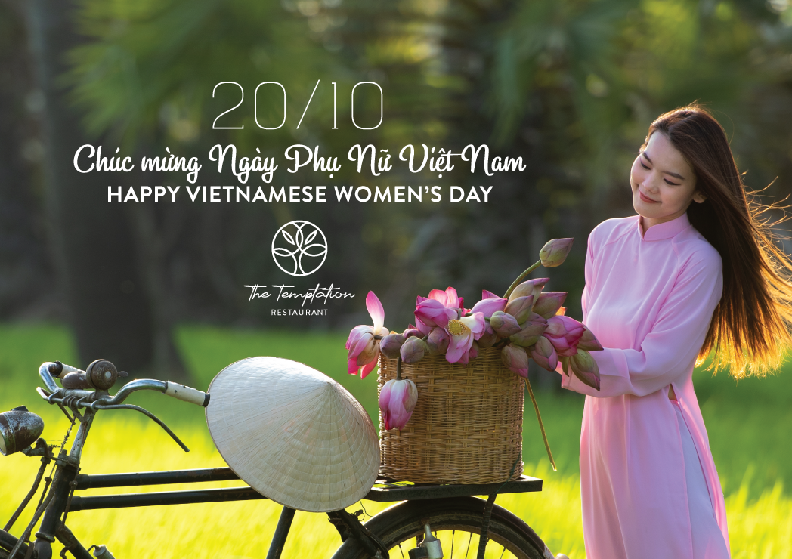

The History Of Women In Vietnam
During the course of our research for this holiday, we came across a lot about the history of women in Vietnam. Although we can’t go into detail about this entire history, we can cover some of the major points that we think everyone observing Vietnamese Women’s Day is going to want to know about.
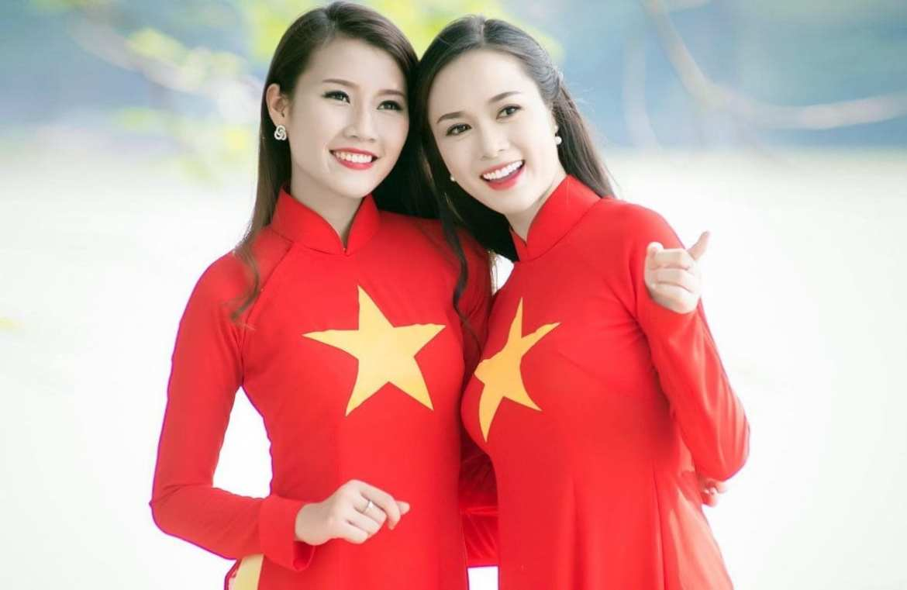
We think one of the best ways to highlight the history of women in Vietnam is through Vietnam’s Women Union. This organization was founded under the Vietnam Communist Party and was created to address the importance of gender equality. This organization has chased the advancement of women in many different areas of society, but they also fail to fully back true equality between men and women. This is due to the organization stressing the importance of Confucian doctrine-a doctrine that maintains a male-dominated hierarchy remains in place.
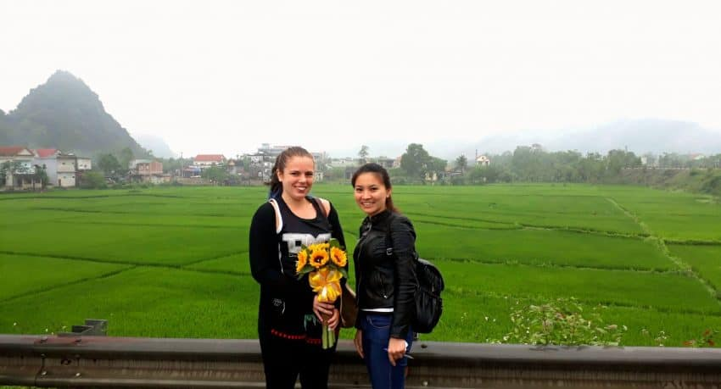
Over the years, women’s rights have continued to expand and women have continued to accept an ever-increasing role in Vietnam. Nowadays, Vietnam has some of the highest numbers of women working in the workforce in the world and the second most women in senior management positions among Asian countries. However, there’s still a lot of work to be done in Vietnam before there can be true equality between men and women.

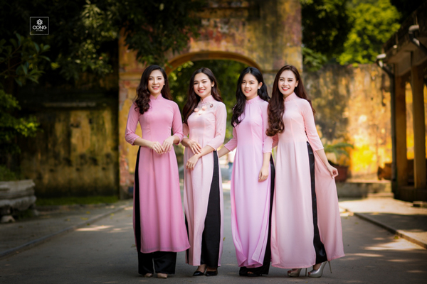

Observing Vietnamese Women’s Day
This holiday is observed in a variety of different ways. For one, women also receive gifts from their male counterparts and/or relatives on this day. These gifts could be anything from flowers to food. Another thing that occurs on this day is that women’s achievements throughout history are remembered and honored. And finally, it’s a day that people use to continue the fight for women’s equality in Vietnam. People observing this holiday or those wishing to spread the word about it can use the hashtag #VietnameseWomensDay.

