**Christmas ( X’mas)**

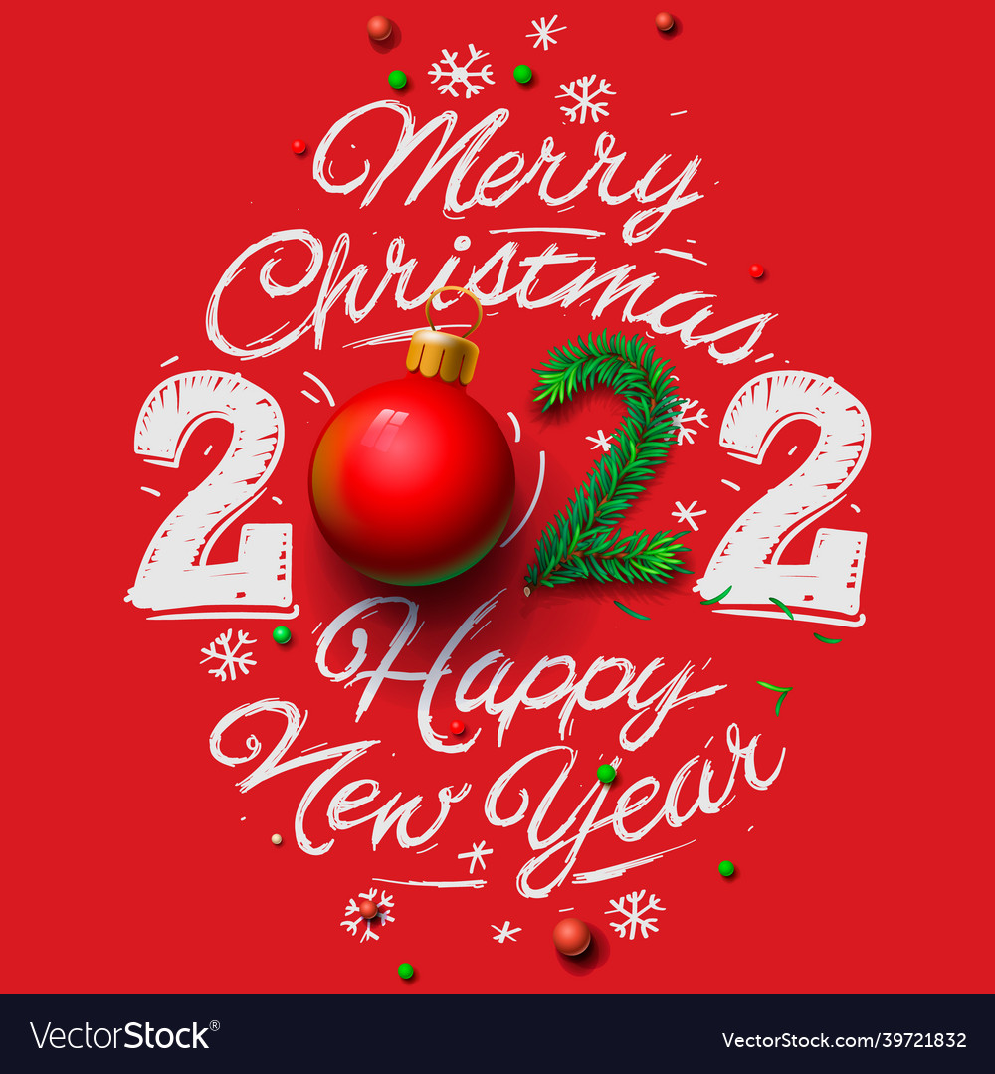

**Introduction**

Christmas is a festival of Christians.

It is celebrated every year on the 25th of December.

But in today’s time, the festival of Christmas has surpassed the religious boundaries and became the symbol of the Holistic culture the winters in December carrier festive feeling.

Christmas is the season of joy, peace, and happiness.

It is the particular season set aside to celebrate the birth of [Jesus Christ](https://en.wikipedia.org/wiki/Jesus).

Festival Christmas lasts for 12 days from 25th December (Jesus’s birth) to 6th January (Epiphany).

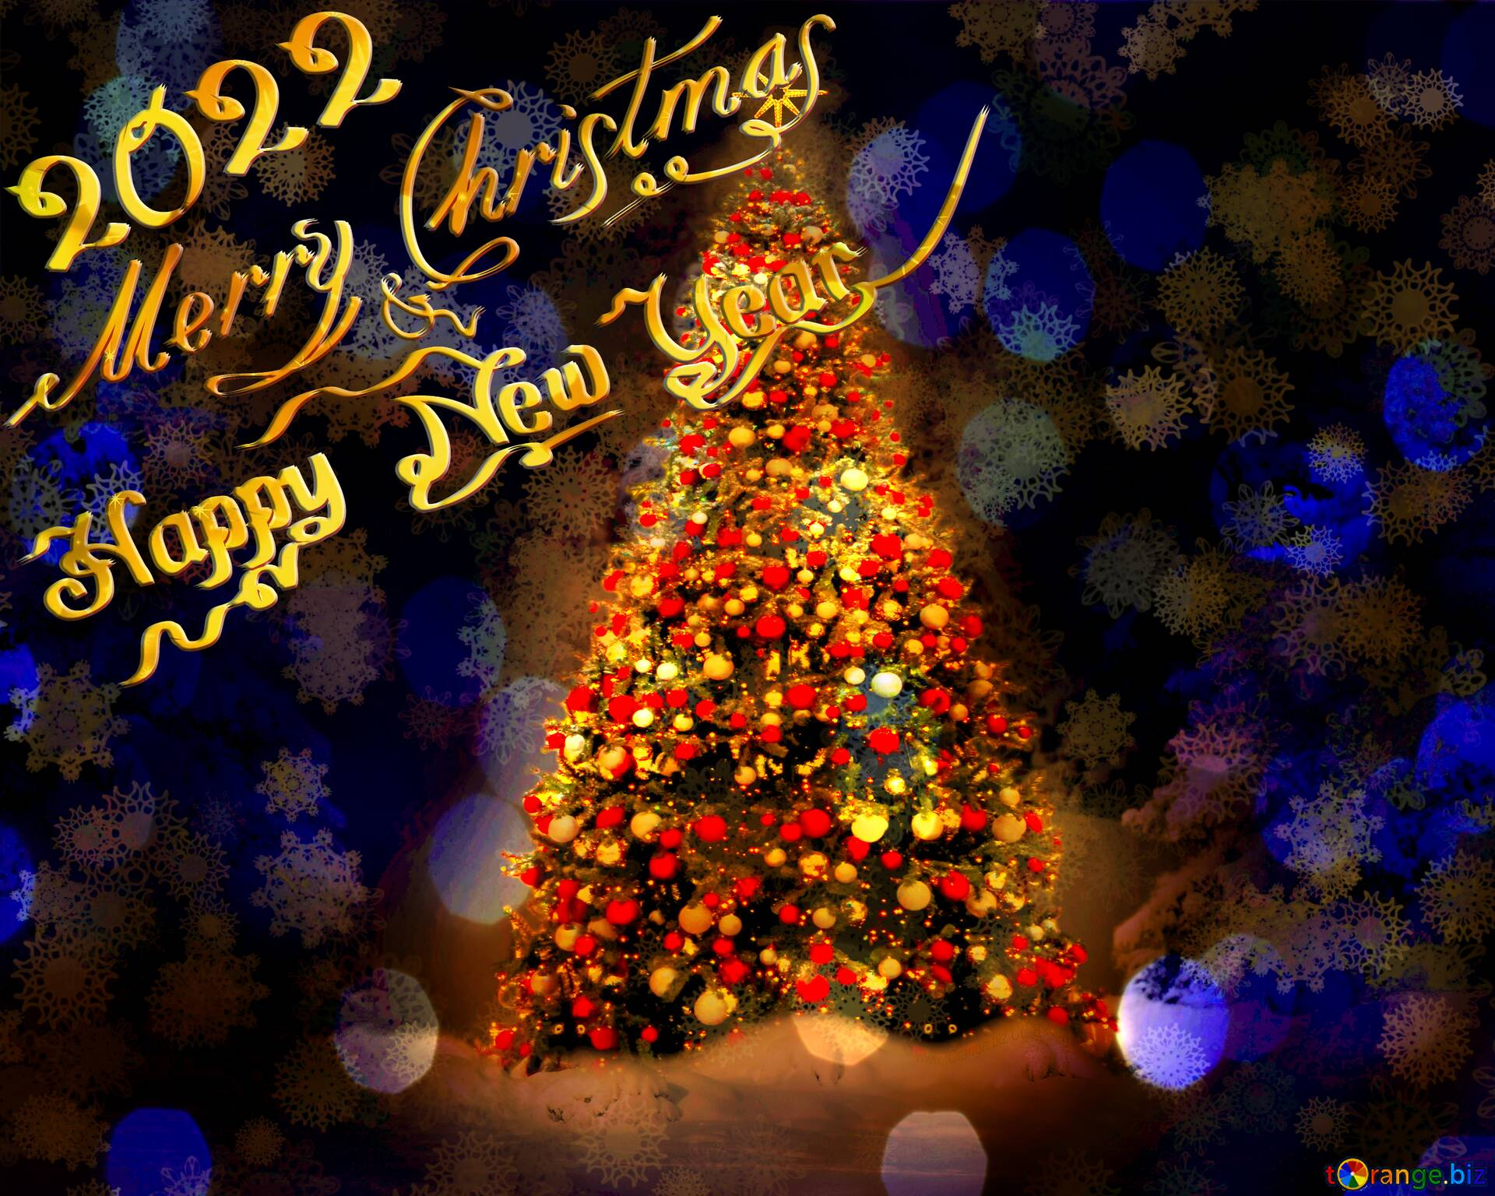

**Preparations for Christmas**

Christmas is a cultural festival and tells a lot of preparation.

It is a public holiday, and so people get a Christmas break to celebrate it.

People do shopping on Christmas and decorative items like food, cake, sweets, decorating lights, and other things.

Many Schools and Churches prepare a song for skits to be performed on Christmas Day, which is usually about the stories of the birth of Jesus Christ as in the Bible.

The church and schools are also being decorated for this special event; traveling plans for families are also made with friends.

You would like to spend your Christmas holiday in a beautiful place.

Christmas eve is also a day when we are still preparing for Christmas. By packing gifts and decorating the tree and house.



**Celebrations**

Christmas Day is associated with the number of festivals all over the world, including numerous people who are generally known, Christian.

Activities on Christmas Day are usually very few because everything was prepared in advance on the eve the day begins with an account on at 11:59 p.m. whereby people shout in celebration when it gets to midnight, Christmas carols are played on radios and television to mark the day.

Most families start by going to Church where performances and songs are done, then later they join their families to exchange gifts and celebrate with food and music.

Happiness during Christmas is like nothing else.

Santa Claus or Father Christmas is a figure originating from the Western Christian culture, which is believed to bring gifts to disciplined children during Christmas.

Children tend to behave well as they anticipate gifts from Santa. Santa Claus is one of the critical parts of the celebrations of Christmas.

Santa gives gifts to the good children on Christmas eve, which is on the 24th December night for that children sleep early on this day hoping to get a gift from Santa Claus when they get up the next morning.

The famous poem Jingle Bell celebrates the coming of Santa to give away the gifts.



**Countries Which Do Not Celebrate Christmas**

As Christmas is celebrated in many countries, there are few countries where Christmas is certainly not a formal festival which includes Afghanistan and Bhutan, Cambodia, China, except Hong Kong and Macau, North Korea, Oman, Pakistan, Thailand, Turkey, Turkmenistan, The United Arab Emirates among others however with the changing times even people from these countries have started to celebrate this festival.



**Christmas in India**

India has a substantial population of Christians; moreover, being a secular country festival of all religions is being celebrated with equal charge and electricity.

Christmas is not different from festivals celebrated in India, people from all religion and Faith celebrate it.

Whether in India, there are many questions about this festival. It is made with full joy and happiness in India by everyone.



**Conclusion**

Christmas is a festival which is celebrated by people from all religions and Faith.

Worldwide despite it being a Christian festival, it is the essence of this festival, which Unites the people so much.

We should learn the importance of such unity from this festival, and despite our religious differences, we should all celebrate the festival together.

Festivals are probably a medium that has the power to keep people United for the betterment of humanity in the future.

In conclusion, Christmas is the best time of the year for both children and adults too.

