**Road Symbol Signs**

[[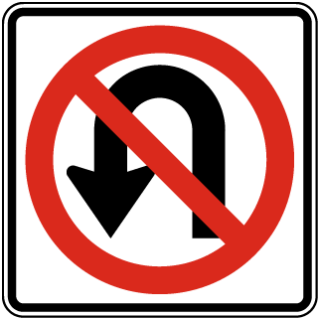](https://www.safetysign.com/products/8670/no-u-turn-symbol-sign?s=st1zsk1r2bzgpn71zbp18l)](https://www.safetysign.com/products/8670/no-u-turn-symbol-sign?s=st1zsk1r2bzgpn71zbp18l" \o "No U-Turn Sign)

**[No U-Turn Sign](https://www.safetysign.com/products/8670/no-u-turn-symbol-sign?s=st1zsk1r2bzgpn71zbp18l" \o "No U-Turn Sign)**

[[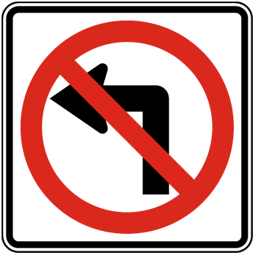](https://www.safetysign.com/products/8669/no-left-turn-sign?s=st1zsk1r28zgpn7pzbp18l)](https://www.safetysign.com/products/8669/no-left-turn-sign?s=st1zsk1r28zgpn7pzbp18l" \o "No Left Turn Sign)

[No Left Turn Sign](https://www.safetysign.com/products/8668/no-right-turn-sign?s=st1zsk1r26zgpn7mzbp18l" \o "No Right Turn Sign)

**[No Right Turn Sign](https://www.safetysign.com/products/8668/no-right-turn-sign?s=st1zsk1r26zgpn7mzbp18l" \o "No Right Turn Sign)**[[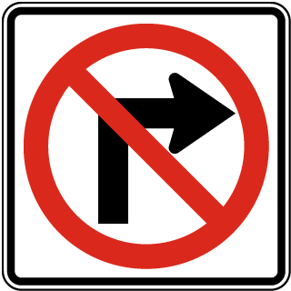](https://www.safetysign.com/products/8668/no-right-turn-sign?s=st1zsk1r26zgpn7mzbp18l)](https://www.safetysign.com/products/8668/no-right-turn-sign?s=st1zsk1r26zgpn7mzbp18l" \o "No Right Turn Sign)

**[MUTCD R3-1](https://www.safetysign.com/products/8668/no-right-turn-sign?s=st1zsk1r26zgpn7mzbp18l" \o "No Right Turn Sign)**

[Item Y2730](https://www.safetysign.com/products/8668/no-right-turn-sign?s=st1zsk1r26zgpn7mzbp18l" \o "No Right Turn Sign)

* [TWEAKABLE](https://www.safetysign.com/products/8668/no-right-turn-sign?s=st1zsk1r26zgpn7mzbp18l" \o "No Right Turn Sign)

No Right Tủn

[[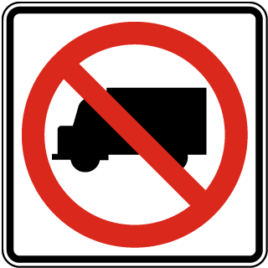](https://www.safetysign.com/products/8672/no-trucks-sign?s=st1zsk1r2gzgpn7kzbp18l)](https://www.safetysign.com/products/8672/no-trucks-sign?s=st1zsk1r2gzgpn7kzbp18l" \o "No Trucks Sign)

**[No Trucks Sign](https://www.safetysign.com/products/8672/no-trucks-sign?s=st1zsk1r2gzgpn7kzbp18l" \o "No Trucks Sign)**

**[MUTCD R5-2](https://www.safetysign.com/products/8672/no-trucks-sign?s=st1zsk1r2gzgpn7kzbp18l" \o "No Trucks Sign)**

[Item Y2737](https://www.safetysign.com/products/8672/no-trucks-sign?s=st1zsk1r2gzgpn7kzbp18l" \o "No Trucks Sign)

* [TWEAKABLE](https://www.safetysign.com/products/8672/no-trucks-sign?s=st1zsk1r2gzgpn7kzbp18l" \o "No Trucks Sign)

[[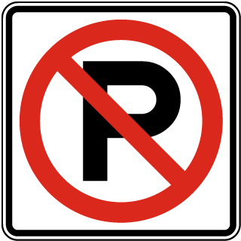](https://www.safetysign.com/products/8671/international-no-parking-symbol-sign?s=st1zsk1r2dzgpn7hzbp18l)](https://www.safetysign.com/products/8671/international-no-parking-symbol-sign?s=st1zsk1r2dzgpn7hzbp18l" \o "No Parking Sign)

**[No Parking Sign](https://www.safetysign.com/products/8671/international-no-parking-symbol-sign?s=st1zsk1r2dzgpn7hzbp18l" \o "No Parking Sign)**

**[MUTCD R8-3](https://www.safetysign.com/products/8671/international-no-parking-symbol-sign?s=st1zsk1r2dzgpn7hzbp18l" \o "No Parking Sign)**

[Item Y2733](https://www.safetysign.com/products/8671/international-no-parking-symbol-sign?s=st1zsk1r2dzgpn7hzbp18l" \o "No Parking Sign)

* [TWEAKABLE](https://www.safetysign.com/products/8671/international-no-parking-symbol-sign?s=st1zsk1r2dzgpn7hzbp18l" \o "No Parking Sign)

[[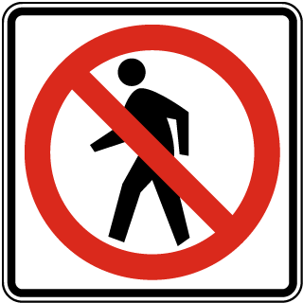](https://www.safetysign.com/products/8673/no-pedestrian-crossing-sign?s=st1zsk1r2jzgpn7fzbp18l)](https://www.safetysign.com/products/8673/no-pedestrian-crossing-sign?s=st1zsk1r2jzgpn7fzbp18l" \o "No Pedestrian Traffic Sign)

**[No Pedestrian Traffic Sign](https://www.safetysign.com/products/8673/no-pedestrian-crossing-sign?s=st1zsk1r2jzgpn7fzbp18l" \o "No Pedestrian Traffic Sign)**

**[MUTCD R9-3a](https://www.safetysign.com/products/8673/no-pedestrian-crossing-sign?s=st1zsk1r2jzgpn7fzbp18l" \o "No Pedestrian Traffic Sign)**

[Item Y2739](https://www.safetysign.com/products/8673/no-pedestrian-crossing-sign?s=st1zsk1r2jzgpn7fzbp18l" \o "No Pedestrian Traffic Sign)

[[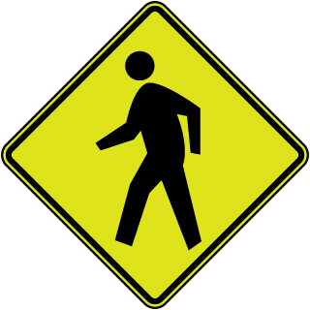](https://www.safetysign.com/products/8526/pedestrian-crossing-diamond-sign?s=st1zsk1qcszgpn7czbp18l)](https://www.safetysign.com/products/8526/pedestrian-crossing-diamond-sign?s=st1zsk1qcszgpn7czbp18l" \o "Pedestrian Crossing Sign)

**[Pedestrian Crossing Sign](https://www.safetysign.com/products/8526/pedestrian-crossing-diamond-sign?s=st1zsk1qcszgpn7czbp18l" \o "Pedestrian Crossing Sign)**

**[MUTCD W11-2](https://www.safetysign.com/products/8526/pedestrian-crossing-diamond-sign?s=st1zsk1qcszgpn7czbp18l" \o "Pedestrian Crossing Sign)**

[Item X5642](https://www.safetysign.com/products/8526/pedestrian-crossing-diamond-sign?s=st1zsk1qcszgpn7czbp18l" \o "Pedestrian Crossing Sign)

* [TWEAKABLE](https://www.safetysign.com/products/8526/pedestrian-crossing-diamond-sign?s=st1zsk1qcszgpn7czbp18l" \o "Pedestrian Crossing Sign)

[[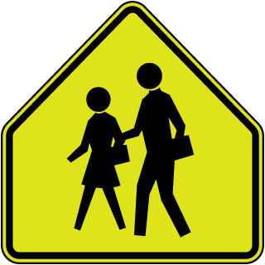](https://www.safetysign.com/products/8529/pedestrian-crossing-pentagon-sign?s=st1zsk1qcwzgpn79zbp18l)](https://www.safetysign.com/products/8529/pedestrian-crossing-pentagon-sign?s=st1zsk1qcwzgpn79zbp18l" \o "School Zone Sign)

**[School Zone Sign](https://www.safetysign.com/products/8529/pedestrian-crossing-pentagon-sign?s=st1zsk1qcwzgpn79zbp18l" \o "School Zone Sign)**

**[MUTCD S1-1](https://www.safetysign.com/products/8529/pedestrian-crossing-pentagon-sign?s=st1zsk1qcwzgpn79zbp18l" \o "School Zone Sign)**

[Item X5646](https://www.safetysign.com/products/8529/pedestrian-crossing-pentagon-sign?s=st1zsk1qcwzgpn79zbp18l" \o "School Zone Sign)

[[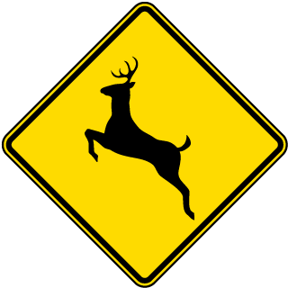](https://www.safetysign.com/products/8663/deer-crossing-sign?s=st1zsk1r1vzgpn77zbp18l)](https://www.safetysign.com/products/8663/deer-crossing-sign?s=st1zsk1r1vzgpn77zbp18l" \o "Deer Crossing Sign)

**[Deer Crossing Sign](https://www.safetysign.com/products/8663/deer-crossing-sign?s=st1zsk1r1vzgpn77zbp18l" \o "Deer Crossing Sign)**

**[MUTCD W11-3](https://www.safetysign.com/products/8663/deer-crossing-sign?s=st1zsk1r1vzgpn77zbp18l" \o "Deer Crossing Sign)**

[Item Y2365](https://www.safetysign.com/products/8663/deer-crossing-sign?s=st1zsk1r1vzgpn77zbp18l" \o "Deer Crossing Sign)

* [TWEAKABLE](https://www.safetysign.com/products/8663/deer-crossing-sign?s=st1zsk1r1vzgpn77zbp18l" \o "Deer Crossing Sign)

[[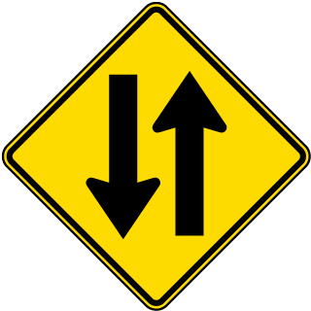](https://www.safetysign.com/products/8658/two-way-street-sign?s=st1zsk1r1lzgpn75zbp18l)](https://www.safetysign.com/products/8658/two-way-street-sign?s=st1zsk1r1lzgpn75zbp18l" \o "Two Way Street Sign)

**[Two Way Street Sign](https://www.safetysign.com/products/8658/two-way-street-sign?s=st1zsk1r1lzgpn75zbp18l" \o "Two Way Street Sign)**

[Item Y2352](https://www.safetysign.com/products/8658/two-way-street-sign?s=st1zsk1r1lzgpn75zbp18l" \o "Two Way Street Sign)

[[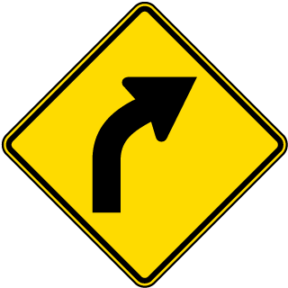](https://www.safetysign.com/products/8657/right-curve-ahead-sign?s=st1zsk1r1jzgpn73zbp18l)](https://www.safetysign.com/products/8657/right-curve-ahead-sign?s=st1zsk1r1jzgpn73zbp18l" \o "Right Curve Ahead Sign)

**[Right Curve Ahead Sign](https://www.safetysign.com/products/8657/right-curve-ahead-sign?s=st1zsk1r1jzgpn73zbp18l" \o "Right Curve Ahead Sign)**

**[MUTCD W1-2R](https://www.safetysign.com/products/8657/right-curve-ahead-sign?s=st1zsk1r1jzgpn73zbp18l" \o "Right Curve Ahead Sign)**

[Item Y2351](https://www.safetysign.com/products/8657/right-curve-ahead-sign?s=st1zsk1r1jzgpn73zbp18l" \o "Right Curve Ahead Sign)

[[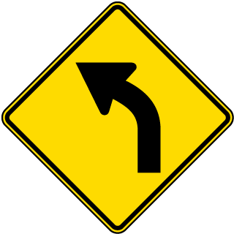](https://www.safetysign.com/products/8665/left-curve-ahead-sign?s=st1zsk1r20zgpn7rzbp18l)](https://www.safetysign.com/products/8665/left-curve-ahead-sign?s=st1zsk1r20zgpn7rzbp18l" \o "Left Curve Ahead Sign)

**[Left Curve Ahead Sign](https://www.safetysign.com/products/8665/left-curve-ahead-sign?s=st1zsk1r20zgpn7rzbp18l" \o "Left Curve Ahead Sign)**

**[MUTCD W1-2L](https://www.safetysign.com/products/8665/left-curve-ahead-sign?s=st1zsk1r20zgpn7rzbp18l" \o "Left Curve Ahead Sign)**

[Item Y2367](https://www.safetysign.com/products/8665/left-curve-ahead-sign?s=st1zsk1r20zgpn7rzbp18l" \o "Left Curve Ahead Sign)

[[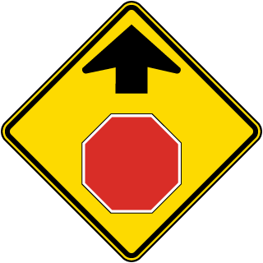](https://www.safetysign.com/products/8662/stop-ahead-sign?s=st1zsk1r1szgpn7nzbp18l)](https://www.safetysign.com/products/8662/stop-ahead-sign?s=st1zsk1r1szgpn7nzbp18l" \o "Stop Ahead Sign)

**[Stop Ahead Sign](https://www.safetysign.com/products/8662/stop-ahead-sign?s=st1zsk1r1szgpn7nzbp18l" \o "Stop Ahead Sign)**

**[MUTCD W3-1](https://www.safetysign.com/products/8662/stop-ahead-sign?s=st1zsk1r1szgpn7nzbp18l" \o "Stop Ahead Sign)**

[Item Y2360](https://www.safetysign.com/products/8662/stop-ahead-sign?s=st1zsk1r1szgpn7nzbp18l" \o "Stop Ahead Sign)

[[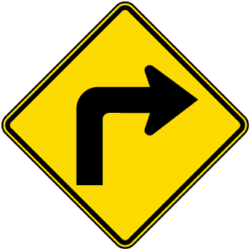](https://www.safetysign.com/products/8656/right-turn-ahead-sign?s=st1zsk1r1gzgpn7lzbp18l)](https://www.safetysign.com/products/8656/right-turn-ahead-sign?s=st1zsk1r1gzgpn7lzbp18l" \o "Right Turn Ahead Sign)

**[Right Turn Ahead Sign](https://www.safetysign.com/products/8656/right-turn-ahead-sign?s=st1zsk1r1gzgpn7lzbp18l" \o "Right Turn Ahead Sign)**

**[MUTCD W1-1R](https://www.safetysign.com/products/8656/right-turn-ahead-sign?s=st1zsk1r1gzgpn7lzbp18l" \o "Right Turn Ahead Sign)**

[Item Y2350](https://www.safetysign.com/products/8656/right-turn-ahead-sign?s=st1zsk1r1gzgpn7lzbp18l" \o "Right Turn Ahead Sign)

[[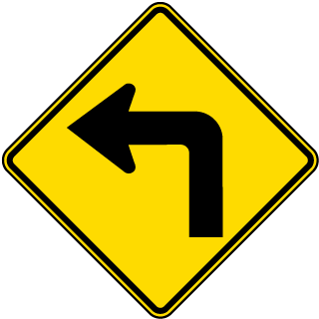](https://www.safetysign.com/products/8664/left-turn-ahead-sign?s=st1zsk1r1xzgpn7jzbp18l)](https://www.safetysign.com/products/8664/left-turn-ahead-sign?s=st1zsk1r1xzgpn7jzbp18l" \o "Left Turn Ahead Sign)

**[Left Turn Ahead Sign](https://www.safetysign.com/products/8664/left-turn-ahead-sign?s=st1zsk1r1xzgpn7jzbp18l" \o "Left Turn Ahead Sign)**

**[MUTCD W1-1L](https://www.safetysign.com/products/8664/left-turn-ahead-sign?s=st1zsk1r1xzgpn7jzbp18l" \o "Left Turn Ahead Sign)**

[Item Y2366](https://www.safetysign.com/products/8664/left-turn-ahead-sign?s=st1zsk1r1xzgpn7jzbp18l" \o "Left Turn Ahead Sign)

[[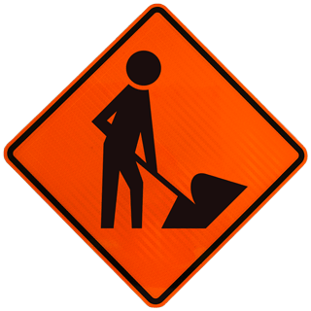](https://www.safetysign.com/products/8507/men-at-work-sign?s=st1zsk1qbyzgpn7gzbp18l)](https://www.safetysign.com/products/8507/men-at-work-sign?s=st1zsk1qbyzgpn7gzbp18l" \o "Men At Work Sign)

**[Men At Work Sign](https://www.safetysign.com/products/8507/men-at-work-sign?s=st1zsk1qbyzgpn7gzbp18l" \o "Men At Work Sign)**

**[MUTCD W21-1](https://www.safetysign.com/products/8507/men-at-work-sign?s=st1zsk1qbyzgpn7gzbp18l" \o "Men At Work Sign)**

[Item X4605](https://www.safetysign.com/products/8507/men-at-work-sign?s=st1zsk1qbyzgpn7gzbp18l" \o "Men At Work Sign)

[[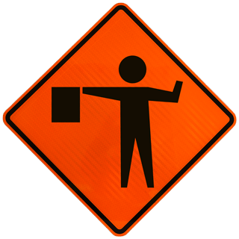](https://www.safetysign.com/products/8459/flagger-ahead-sign?s=st1zsk1q97zgpn7dzbp18l)](https://www.safetysign.com/products/8459/flagger-ahead-sign?s=st1zsk1q97zgpn7dzbp18l" \o "Flagger Ahead Sign)

**[Flagger Ahead Sign](https://www.safetysign.com/products/8459/flagger-ahead-sign?s=st1zsk1q97zgpn7dzbp18l" \o "Flagger Ahead Sign)**

**[MUTCD W20-7](https://www.safetysign.com/products/8459/flagger-ahead-sign?s=st1zsk1q97zgpn7dzbp18l" \o "Flagger Ahead Sign)**

[Item X4569](https://www.safetysign.com/products/8459/flagger-ahead-sign?s=st1zsk1q97zgpn7dzbp18l" \o "Flagger Ahead Sign)

[[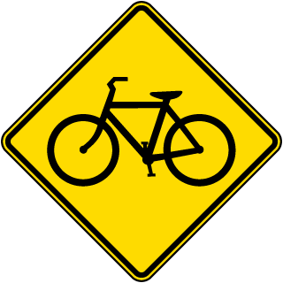](https://www.safetysign.com/products/8661/bicycle-crossing-sign?s=st1zsk1r1rzgpn78zbp18l)](https://www.safetysign.com/products/8661/bicycle-crossing-sign?s=st1zsk1r1rzgpn78zbp18l" \o "Bicycle Traffic Warning Sign)

**[Bicycle Traffic Warning Sign](https://www.safetysign.com/products/8661/bicycle-crossing-sign?s=st1zsk1r1rzgpn78zbp18l" \o "Bicycle Traffic Warning Sign)**

**[MUTCD W11-1](https://www.safetysign.com/products/8661/bicycle-crossing-sign?s=st1zsk1r1rzgpn78zbp18l" \o "Bicycle Traffic Warning Sign)**

[Item Y2359](https://www.safetysign.com/products/8661/bicycle-crossing-sign?s=st1zsk1r1rzgpn78zbp18l" \o "Bicycle Traffic Warning Sign)

* [TWEAKABLE](https://www.safetysign.com/products/8661/bicycle-crossing-sign?s=st1zsk1r1rzgpn78zbp18l" \o "Bicycle Traffic Warning Sign)

[[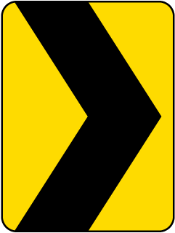](https://www.safetysign.com/products/8411/chevron-alignment-sign?s=st1zsk1q76zgpn7qzbp18l)](https://www.safetysign.com/products/8411/chevron-alignment-sign?s=st1zsk1q76zgpn7qzbp18l" \o "Chevron Alignment Sign)

**[Chevron Alignment Sign](https://www.safetysign.com/products/8411/chevron-alignment-sign?s=st1zsk1q76zgpn7qzbp18l" \o "Chevron Alignment Sign)**

**[MUTCD W1-8](https://www.safetysign.com/products/8411/chevron-alignment-sign?s=st1zsk1q76zgpn7qzbp18l" \o "Chevron Alignment Sign)**

[Item X4433](https://www.safetysign.com/products/8411/chevron-alignment-sign?s=st1zsk1q76zgpn7qzbp18l" \o "Chevron Alignment Sign)

**Custom Road Symbols**